CPM Project Management using Quick Kanban

Table of Contents

Step 1 create User accounts for your team so you can assign subtasks to them 3

Step 2 capture CPM Project using Quick Kanban 4

Step 2.1 capture the User Story : User Story 001 5

Step 2.2 capture the subtasks ST_001 to ST_008 6

Step 2.3 Export your Project before continuing 8

Step 3 Edit the UserStory (Project) and set the Start date 9

Step 4 Associate Node numbers to the Subtasks 10

Step 5 display the CPM timetable 12

The following Node Diagram describes the sample project we are going to schedule

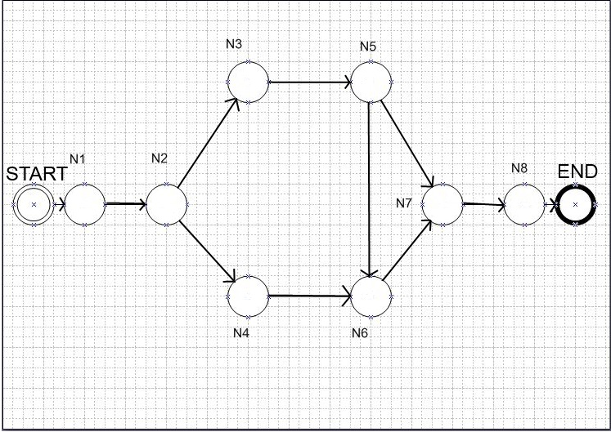

The following chart will be generated by the Quick Kanban program :

Project : Sample Project 001 : User Story 001

|  |  |  |  |  |  |  |  |  |
| --- | --- | --- | --- | --- | --- | --- | --- | --- |
| **SubTask** | **Node Name** | **Duration** | **Earliest Start** | **Earliest Finish** | **Latest Start** | **Latest Finish** | **Slack** | **Is in Critical Path** |
|  | **NODE** | **DAYS** | **ES** | **EF** | **LS** | **LF** | **S** | **CRITICAL** |
| **ST_001** | 1 | 3 |  |  |  |  |  |  |
| **ST_002** | 2 | 4 |  |  |  |  |  |  |
| **ST_003** | 3 | 5 |  |  |  |  |  |  |
| **ST_004** | 4 | 6 |  |  |  |  |  |  |
| **ST_005** | 5 | 7 |  |  |  |  |  |  |
| **ST_006** | 6 | 8 |  |  |  |  |  |  |
| **ST_007** | 7 | 9 |  |  |  |  |  |  |
| **ST_008** | 8 | 10 |  |  |  |  |  |  |

# Step 1 create User accounts for your team so you can assign subtasks to them

In the Home menu press the Management Functions button

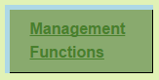

from the Management Functions Menu click on : [3) List and Manage User Stories](http://localhost:8080/QuickKanban/userStory/index)

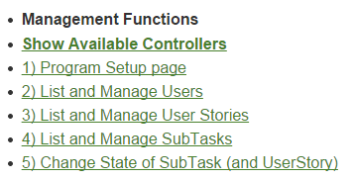

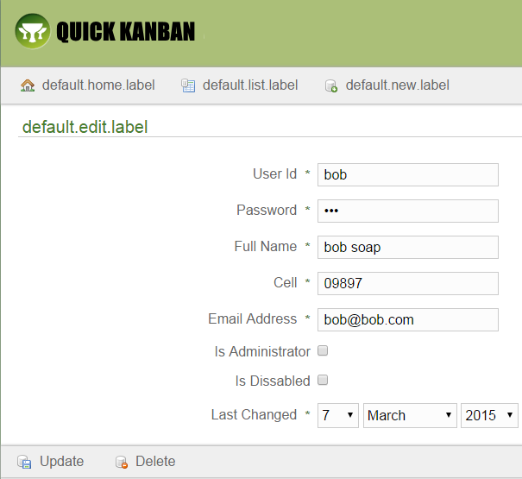

# Step 2 capture CPM Project using Quick Kanban

The next steps as follows

Press the CPM Scheduling button

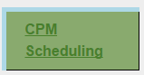

Select next operations from the CPM Scheduling menu:

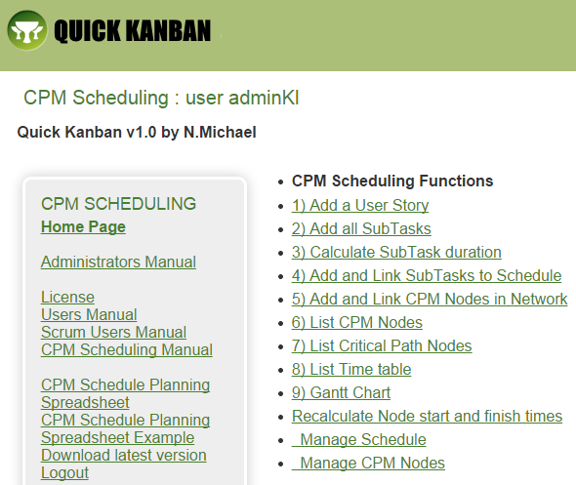

## Step 2.1 capture the User Story : User Story 001

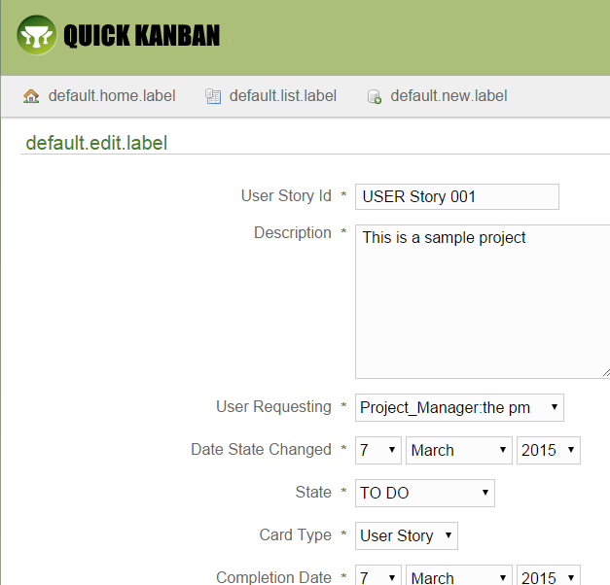

## Step 2.2 capture the subtasks ST_001 to ST_008

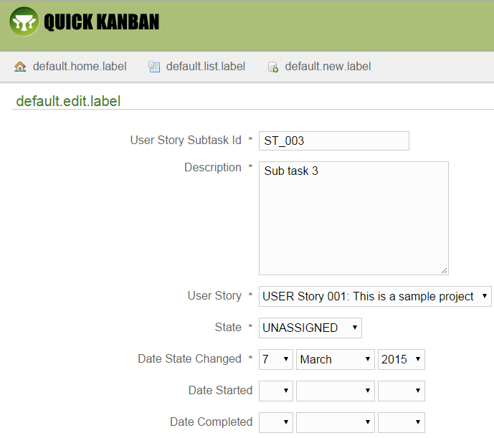

Here are the subtasks captured : 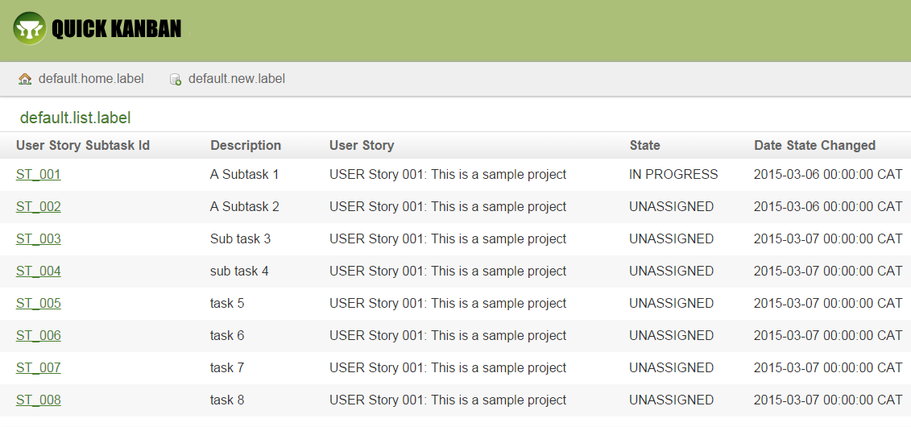

## Step 2.3 Export your Project before continuing

press the Export Functions in the Home page menu

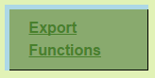

Export both files in the Export Functions (as CSV files)

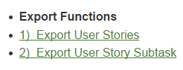

# Step 3 Edit the UserStory (Project) and set the Start date

Select the project Start Date. This will be needed for the CPM functions to create the Timetable

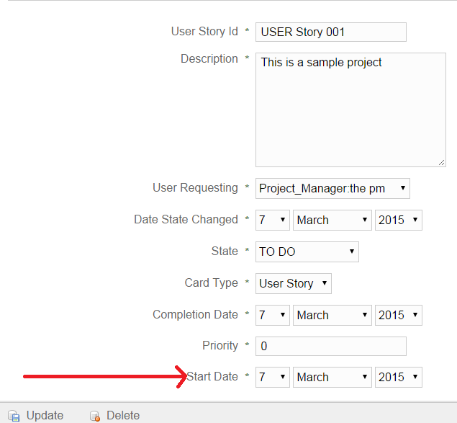

# Step 4 Associate Node numbers to the Subtasks

Click on link 4) Add and Link SubTasks to Schedule from the CPM Scheduling Functions

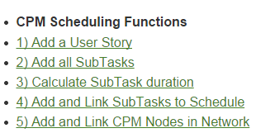

**Now enter a node number from this table for all subtasks which you select from the drop down list:**

|  |  |  |  |  |  |  |  |  |
| --- | --- | --- | --- | --- | --- | --- | --- | --- |
| SubTask | **Node Name** | Duration | Earliest Start | Earliest Finish | Latest Start | Latest Finish | Slack | Is in Critical Path |
|  | **NODE** | DAYS | ES | EF | LS | LF | S | CRITICAL |
| ST_001 | **1** | 3 |  |  |  |  |  |  |
| ST_002 | **2** | 4 |  |  |  |  |  |  |
| ST_003 | **3** | 5 |  |  |  |  |  |  |
| ST_004 | **4** | 6 |  |  |  |  |  |  |
| ST_005 | **5** | 7 |  |  |  |  |  |  |
| ST_006 | **6** | 8 |  |  |  |  |  |  |
| ST_007 | **7** | 9 |  |  |  |  |  |  |
| ST_008 | **8** | 10 |  |  |  |  |  |  |

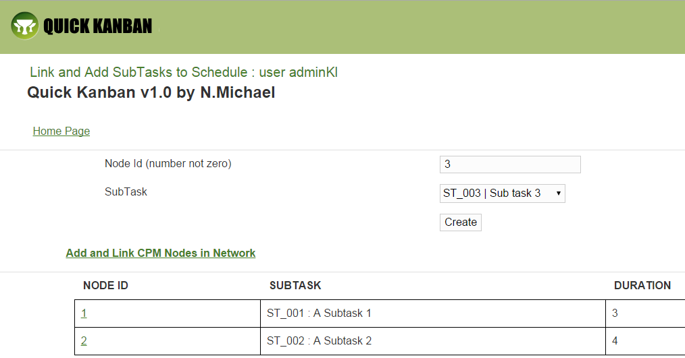

Now click on the link on this page : Add and Link CPM Nodes in Network  
Use this diagram to link all the nodes



If you make a mistake and link the wrong nodes simply click on this link on the bottom of this page:

DELETE ALL NODES (Start again)

With practice you get this right

The Critical Path is displayed as the bottom list on this page :

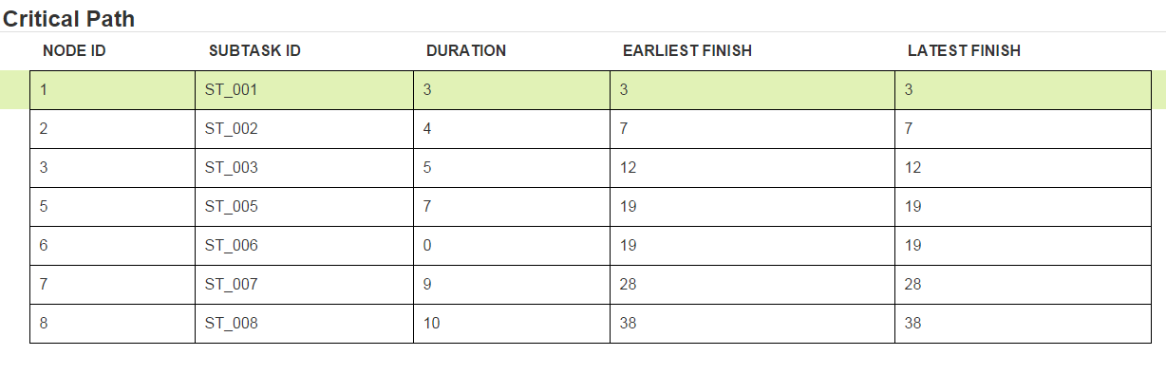

# Step 5 display the CPM timetable

Click on link **8) List Time table** from the CPM Scheduling Functions

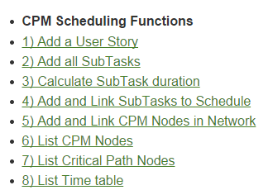

Here is your Project Schedule with critical path durations highlighted:

